Server-client base network
A computer network module one or more powerful computer (servers) provides the different network services and all other user of the computer network (client) access those services to perform the user’s task is know as client/server computer networking module.
In such networking, these exists a central controller called server. A server is a specialized computer that controls the network resources and provides services to other computers in the network.
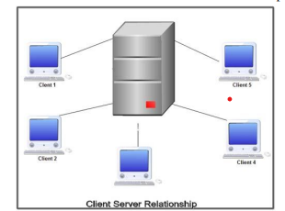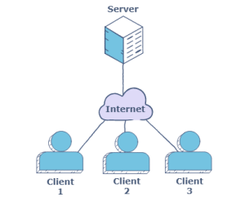

Advantages of Client-Server Architecture
- Improved Data Sharing: Data is retained by usual business processes and manipulated on a server is available for designated users (clients) over an authorized access.
- Integration of Services: Every client is given the opportunity to access corporate information via desktop interface eliminating the necessity to log into a terminal mode or processor.
- Shared Resources Amongst Different Platforms: Application used for client-server model is built regardless of the hardware platform or technical background of the entitled software (operating system software) providing an open computing environment, enforcing users to obtain the services of clients and servers (database, application and communication services).
Data Processing Capability Despite the Location: Client-server users can directly log into a system despite the location or technology of the processors. 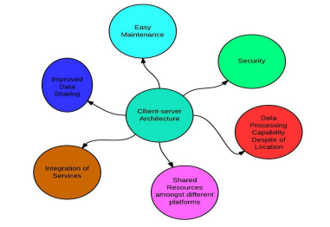

- Easy Maintenance: Client-server architecture is a distributed model representing dispersed responsibilities among independent computers integrated across a network. Therefore, it's easy to replace, repair, upgrade and relocate a server while the client remains unaffected. This unaware change is called Encapsulation.
- Security: Servers have better control access and resources to ensure that only authorized clients can access or manipulate data and server updates are administered effectively.

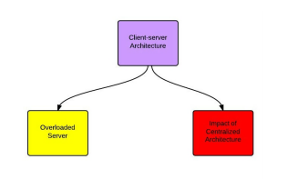
Disadvantages of Client-Server Architecture
- Overloaded Servers: When there are frequent simultaneous client requests, servers severely get overloaded, forming traffic congestion.
- Impact of Centralized Architecture: Since it is centralized, if a critical server fails, client requests are not accomplished. Therefore, client-servers lack the robustness of a good network.

Peer-to-Peer networks
In the peer-to-peer computer network model we simply use the same Workgroup for all the computers and a unique name for each computer in a computer network.
It is practical for workgroups of a dozen or less computers making it common environments, where each PC acts as an independent workstation and maintains its own security that stores data on its own disk but which can share it with all other PCs on the network.
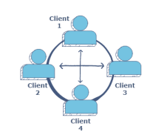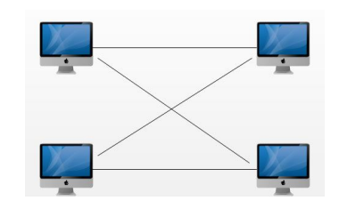

Advantages of Peer-to-Peer Networks
- Such networks are easy to set up and maintain as each computer manages itself.
- It eliminates extra cost required in setting up the server.
- Since each device is master of its own, they an not dependent on other computers for their operations.
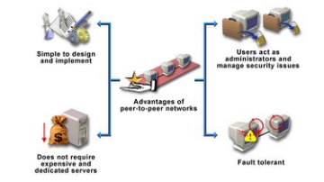

Disadvantages of Peer-to-Peer Networks
- In a peer-to-peer network, the absence of a centralized server makes it difficult to backup data as data is located on different workstations.
- Security is weak as each system manages itself only.
- There is no central point of data storage for file archiving.

Difference between Client-server and Peer-to-Peer Networks
Both peer-to-peer and client-server networks connect computers so that they can share resources from one computer to others such as files, videos, and pictures.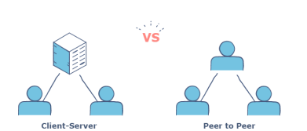

S.No | Client Server Model | Peer-to-Peer Module
1 | It requires costly hardware devices so cost is high. | Cost depends on type of machine used by users.
2 | Offers better security model | Peer to Peer network is less secure.
3 | Network administrators are required to manage the system. | Do not require network administrator to manage the network.
4 | Best module for large networks | Best module for small networks

